Stack Organization
Stack or last-in, first-out (LIFO) list is a useful feature in the CPU. A stack is a storage device that stores information in such a manner that “the item stored last is the first item retrieved”.
The operation of a stack can be compared to a stack of trays. The last tray placed on top of the stack is the first to be taken off.
Stack Pointer (SP): The register that holds the address for the stack is called a Stack Pointer (SP) because its value always points at the top item in the stack.
The two operations of a stack are the insertion and deletion of items.
The operation of insertion is called push(or push down). It means pushing a new item on top.
The operation of deletion is called pop(or pop-up). It means removing one item from stack.
Register Stack
A stack can be placed in a portion of a large memory or it can be organized as a collection of finite number of memory words or registers.
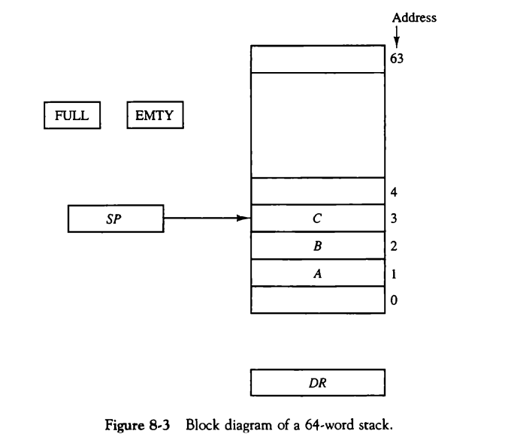
Figure 8-3 shows the organization of a 64-word register stack.
The stack pointer register SP contains a binary number whose value is equal is equal to the address of the word that is currently on top of the stack.
Three items are placed in the stack A, B and C. Item C is on top of stack.
In a 64-word stack, the stack pointer contains 6 bits because 64=2⁶.Since SP has only 6 bits, it cannot exceed a number greater than 63(111111 in binary). When 63 is incremented by 1, the result is 0 because 111111 + 1 = 1000000 in binary but SP can hold only six least significant bits.
Initially, SP is cleared to 0, EMPTY set to 1. If stack is not full means FULL = 0, a new item is inserted with a PUSH operation.
Memory Stack
A stack can exist as a stand-alone unit as in fig 8-3 or can be implemented in a random- access memory attached to a CPU.
The implementation of a stack in the CPU is done by assigning a portion of memory to a stack operation and using a processor register as a stack pointer.
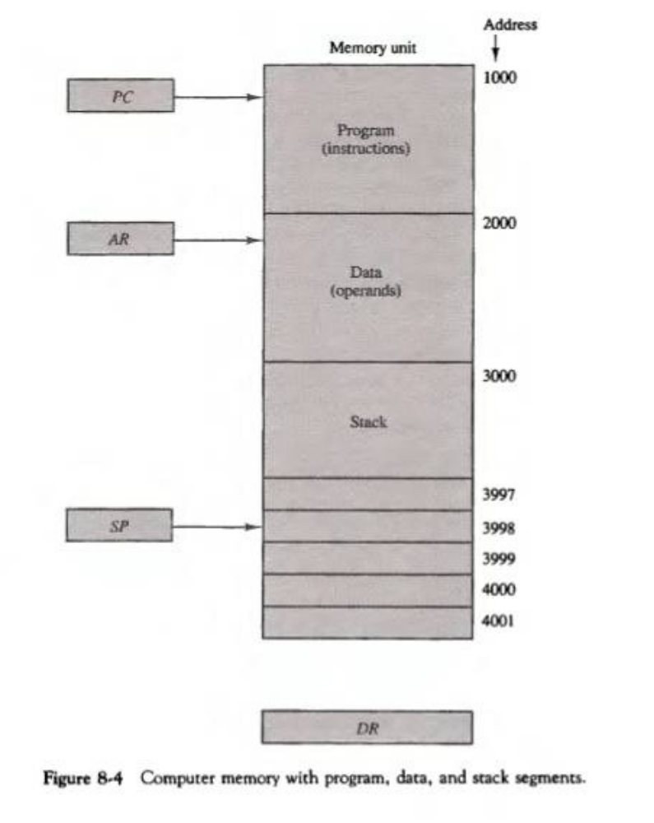
Fig. 8-4 shows a portion of computer memory partitioned into three segments: program, data and stack.
The Program Counter (PC) points at the address of the next instruction in the program.
The Address Register (AR) points at an array of data. SP points at the top of the stack.
The three registers are connected to a common address bus which provides an address for memory. PC is used during the fetch phase to read an instruction. AR is used during the execute phase to read an operand. SP is used to push or pop items into or from the stack.
As shown in FIG. 8-4, the initial value of SP is 4001 and stack grows with decreasing addresses. Thus the first item stored in the stack is at address 4000, the second item is stored at address 3999 and the last address that can be used for the stack is 3000.

